Part 1: Research
There are a few existing apps that allow users to view parking and reserve spots for convenience. For example, SpotHero and ParkWhiz both serve these purposes.
One major difference that my application will include is the ability for customers to leave detailed reviews of the parking garages. Similar to that of Yelp, users will be able to provide a detailed rating out of five stars, include pictures, and also leave their own comments. Furthermore, there would be a rating based on the safety level within the parking garage, as that’s an important factor to most users.
Another key difference of this application is that rather than broadly focusing on different types of parking, this application will specifically only focus on parking garages.

Part 2: Vision and Scope
- Introduction: $oftware Corp is a software development studio that creates different software systems for a variety of clients. We acquired this project upon being approached by a client to develop a new application that works to allow users to find and reserve spots within parking garages.
  - Purpose: Parking garages can tend to present challenges for drivers to easily locate available spots, especially at university, event, and workplace garages. Rather than having to go all the way through a garage, this type of application easily allows users to view the availability ahead of time for better convenience. Ultimately, the purpose of this project is to help drivers more efficiently locate, reserve, and pay for parking spots within parking garages in real time.
  - This document defines the requirements for Smart Parking Platform
  - Scope: This project management plan covers the requirements needed for the app, stakeholders, development teams, project constraints, and existing software research. Certain aspects considered out of scope for this project includes providing physical repair or maintenance for the parking garages if there are issues. Additionally, manually freeing up parking spaces for users, and also covering any costs associated with malfunctioning parking sensors. The scope of this project outlines specifically providing users with the option to reserve a spot at a parking garage location.
Part 3: Software Requirements Specifications (SRS)
Project: Smart Parking Platform
Version: 1.0
Date: 9.10.2026
- Users:
  - Drivers/Customers
  - Parking Operators
  - Customer Service Support
  - App Developers/Software Engineers
- System Environment: This will run on the mobile app and through web.
- Constraints
  - Must run on specific hardware
  - Must require specific authentication
- Assumptions
  - Application has internet/intranet access
  - Parking systems will be continuously looked at by parking operators
- Functional Requirements
  - The system shall allow users to register and log in securely
  - The system should allow users to select, modify, and cancel reservations
  - The system should allows users to generate reports
  - The system should allow users to submit reviews
  - The system shall allow users to process payments
  - The system shall display daily sales reports for operators
  - The system shall automatically generate and email weekly reports for operators
- Non-Functional Requirements
  - The system shall support at least 1,000 concurrent users
  - The system shall update inventory values within 1 second
  - The system shall provide 99.99% uptime
- Use Cases
- Use Case 1
  - Actor: Customer
  - Goal: To find available parking on the app
  - Precondition: User has opened the app
  - Steps:
    - User allows for location to be accessed
    - User selects on parking garage from options
    - User finds available spots
  - Postcondition: User is able to look at the open parking spots in the garage.
- Use Case 2
  - Actor: Customer
  - Goal: To reserve a spot
  - Precondition: User has logged into the app
  - Steps:
    - User enters the desired location
    - User enters their car information
    - User selects an available parking spot
  - Postcondition: User is able to reserve that spot for themselves
- Use Case 3
  - Actor: Customer
  - Goal: Sign up for an account
  - Precondition: New user that has the app open
  - Steps:
    - User opens the app
    - User selects Create An Account
    - User puts in their email information and creates a password
  - Postcondition: The user successfully creates an account
- Use Case 4
  - Actor: Parking Operator
  - Goal: Check on parking availability
  - Precondition: The parking operator is logged into the application
  - Steps:
    - Operator enters in their dashboard
    - Operator is able to view the available and unavailable spots
  - Postcondition: The operator is able to make any necessary changes, or just review the spots
- Use Case 5
  - Actor: Customer
  - Goal: Receive alerts for newly available spots in a full parking garage
  - Precondition: User has notifications enabled in phone settings
  - Steps:
    - User opens the app settings
    - User clicks to allow notifications
    - User locates back to specific parking garage
    - User specifically selects Alert when a spot becomes available
  - Postcondition: The user will receive a notification if a spot becomes available in the selected garage
- Use Case 6
  - Actor: Customer
  - Goal: Receive customer service assistance due to an error
  - Precondition: The customer is facing an issue while using the application
  - Steps:
    - User goes to the applications settings
    - User selects the option to contact customer support
  - Postcondition: The user is connected with real live customer support through message or email.
- Use Case 7
  - Actor: Customer
  - Goal: To check past parking history
  - Precondition: User has previously reserved spots and is logged into the app
  - Steps:
    - User accesses the History section of the app
    - User reviews their past parking reservations
  - Postcondition: User can view their previous parking activity and orders
- Use Case 8
  - Actor: Customer
  - Goal: Receive a copy of their receipt
  - Precondition: Customer has completed a parking payment
  - Steps
    - Driver completes a parking payment
    - Driver selects the option to receive a copy of the receipt via email or text message
  - Postcondition: The customer receives a parking receipt copy
- Use Case 9
  - Actor: Customer
  - Goal: Access the map to view a wide range of parking options
  - Precondition: User is logged into their account
    - User selects the map option
    - User views available parking options with their area
  - Postcondition: The user can view the parking garages within the widespread area
- Use Case 10
  - Actor: Parking Operator
  - Goal: View analytics and data for their parking garage
  - Precondition: Operator is logged into their account
  - Steps:
    - Operator opens their dashboard
    - Operator selects analytics mode
    - Operator is able to view parking data and analytics
  - Postcondition: The operator can view parking data and analytics for their parking garage
- Use Case 11
  - Actor: Customer
  - Goal: Leave a review for a parking garage
  - Precondition: User has already reserved a spot at the garage
  - Steps:
    - User selects the review option
    - User provides a star rating and written comment
    - User submits review
  - Postcondition: Users review is submitted for others to view
- Use Case 12
  - Actor: Parking Operator
  - Goal: Report a customer
  - Precondition: The operator is logged in to their account
  - Steps:
    - Operator selects on settings
    - Operator selects on customer support
    - Operator puts in a ticket to report a customer with evidence
  - Postcondition: Operator is able to report when needed
- Use Case 13
  - Actor: Customer
  - Goal: To cancel a parking reservation
  - Precondition: Customer has already reserved a parking spot
  - Steps:
    - Users selects on their parking reservation
    - Users selects the option to cancel reservation
  - Postcondition: User cancels their previous reservation, and the spot shows as open again within the application.
- Use Case 14
  - Actor: Customer
  - Goal: To add a payment method on their account
  - Precondition: User is logged into the application
  - Steps:
    - User navigates to settings
    - User selects Payment Method option
    - User inputs payment information
  - Postcondition: Their payment method is saved for all future payments.
- Use Case 15
  - Actor: Customer
  - Goal: To view the specifics on a parking garage
  - Precondition: The user is logged in and has already selected a parking garage to view
  - Steps:
    - User clicks the “I” symbol
    - User is shown a pop up with the garages specific information that is available
  - Postcondition: User is able to gain more information in regards to selected garage.

WBS
- Authentication (registration, login, email confirmation)
- Parking:
  - Location permissions
  - View/Select garage
  - View/Select available parking spots
  - Reserve/edit/modify parking reservation
- Payment & Review
  - Enter payment information/receive receipt
  - Submit optional review

Timeline and Gantt chart
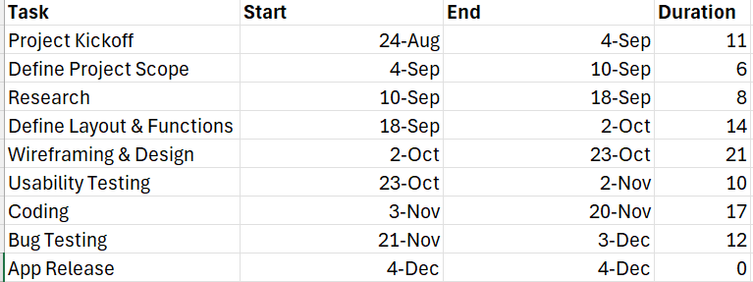

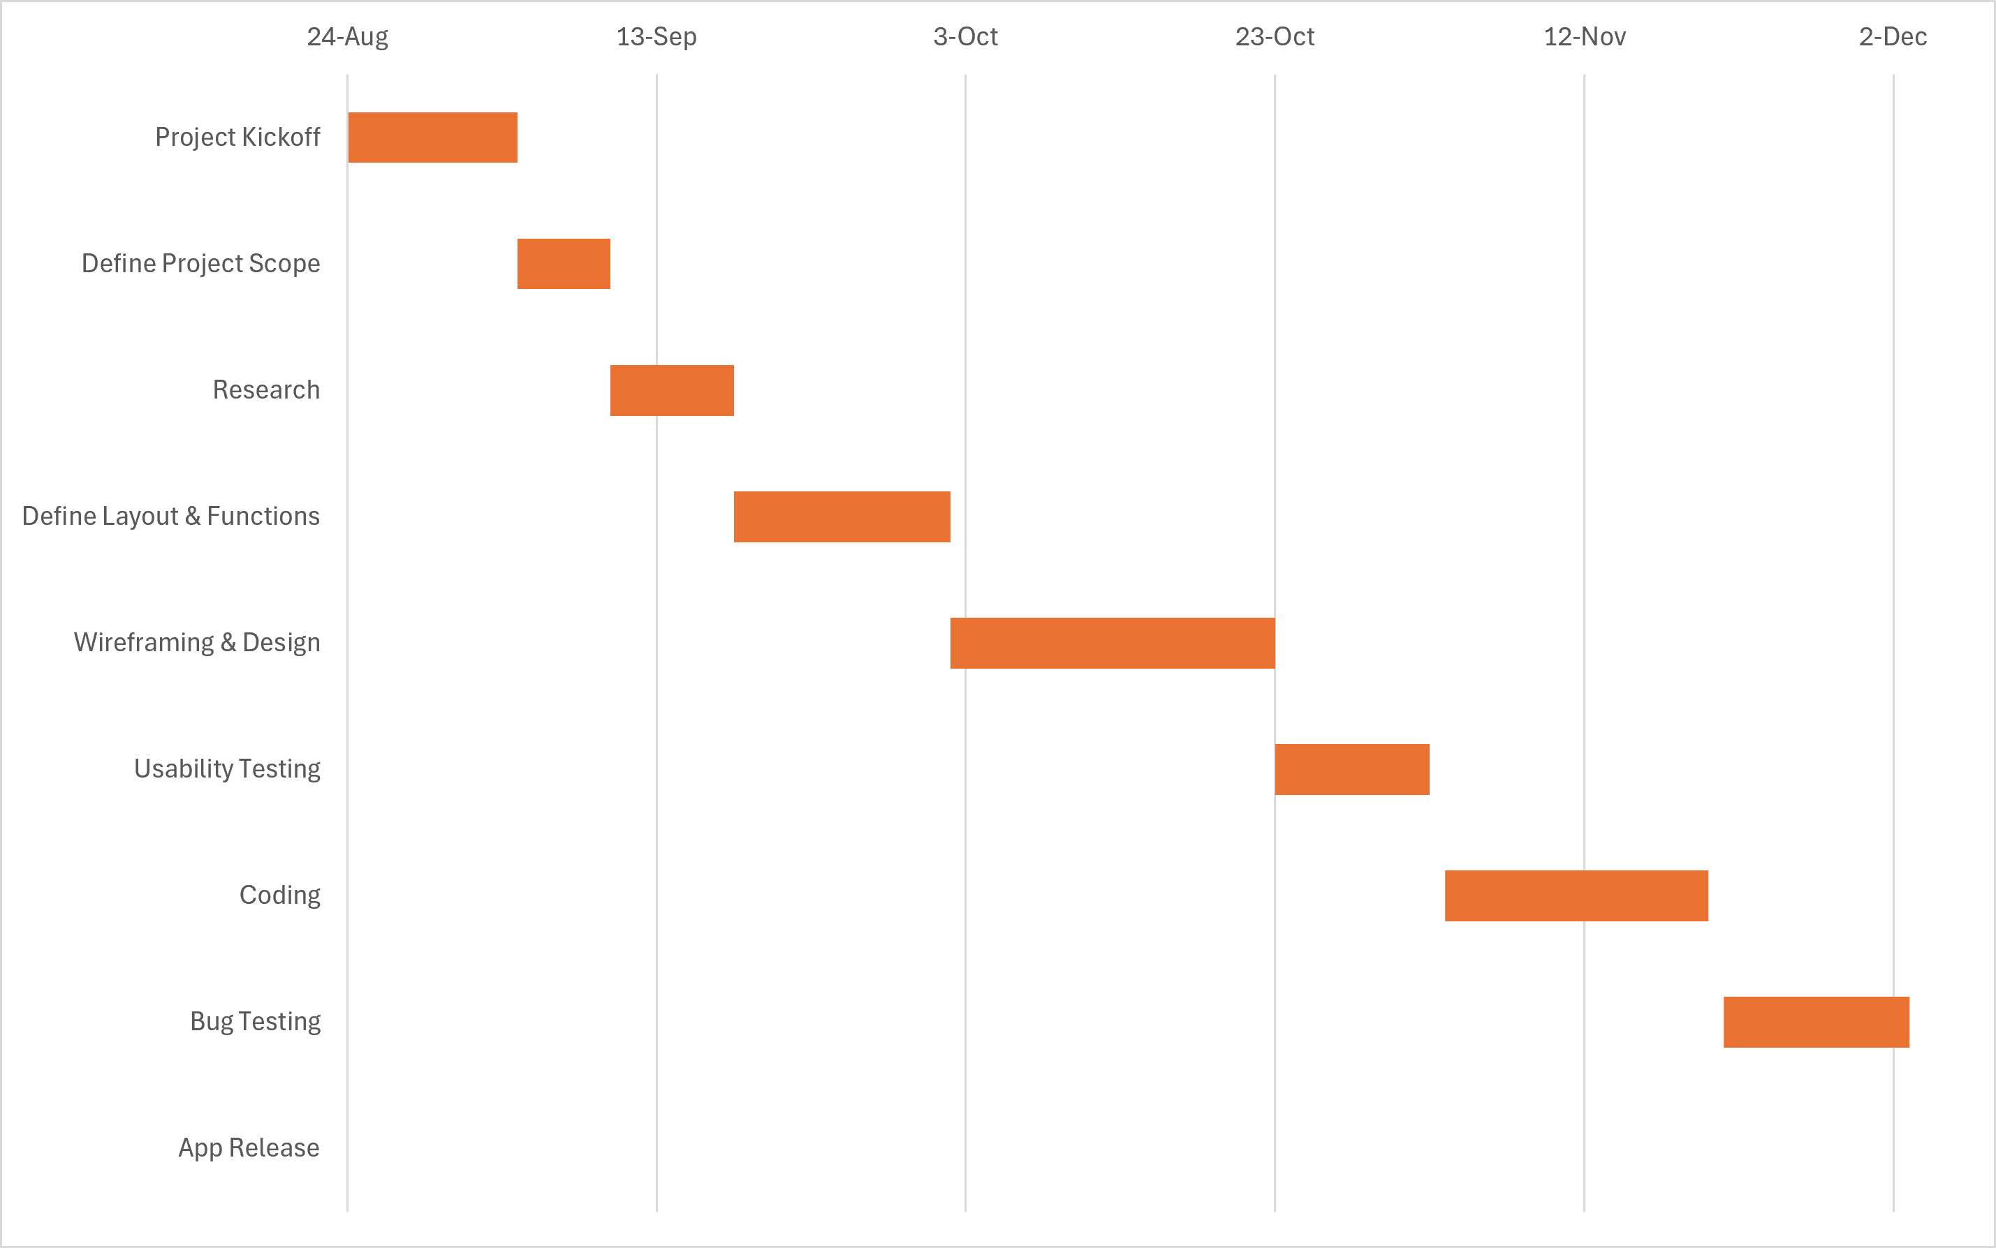

Homework 3

Backlog for Parking App
Login
- Register for an account
- Login to account
- Option for Reset Password
- Two factor Authentication
- Verify account (via email)

UI for operator and user
Operator:
- Design for the dashboard
- Design for customer support chat
- Design for user management profile
- Design for parking garage management screen
- Design for reservation management

For user:
- Design for the login screen
- Design for the homepage
- Accessibility Audit
- Design for the map page
- Design for the checkout screen
- Parking Type/Range filter
- Design for the reviews page
- Search Bar
- Design for the reservations page
- Dark mode toggle for app
- Design for profile page
- Design for the parking lot view screen
- Button design
- Garage safety ratings

Backend processes for operator and user
For user
- Store the user’s login information after creating an account in the database system
- Save the users parking history
- Check the available spots
- Store parking garage’s location on the map
- Create and save the parking reservation
- Save parking reservations edits/changes/deletions
- Putting in payment information
- Processing payment information
- Save payment information
- Save user reviews and ratings
- Upload review photos

For operator
- Manage refunds
- Continuously update the parking spots that are available
- Continuously update the pricing within each garage
- Continuously remove taken parking spots
- Manage incoming reports

Reporting for operator and user
For operator
- Number of users active on the app
- Number of reservations made
- Weekly reporting on revenue made
- Overall user activity

For user
- User’s monthly spending
- Monthly total number of reservations/ parking history
- Number of reservations made
- Most selected parking garages/ frequency at each
- Payment history
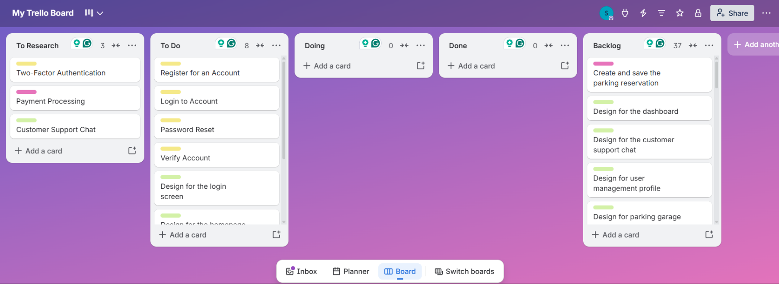
- Parking duration

Homework 4
Technical:
- The app could crash when there is a high volume of users accessing it at the same time.
- During early production, the app could experience frequent freezing or slower performance.
- There is always a risk that the software or technical equipment being used could malfunction or break.
- Need to ensure that everyone has access to the appropriate equipment that they need to complete their work.

Schedule:
- Time zone differences could make it difficult for team members to communicate, which could cause missed deliverables or deadlines.
- One team being late on a deliverable, or the stakeholders giving feedback late could end up pushing back other deadlines.
- Last minute changes could cause pushbacks on deadlines.
- An underestimation of how long task might take could result in team members working past the expected deliverables date.

Financial:
- During bug testing, unexpected technical problems may require additional cost to fix it.
- As the project progresses, the budget may be found to not be sufficient to cover the resources and work that is being required.
- The project might require additional compensation for labor costs if the workload becomes higher than originally planned.
- If there is a need for additional resources and equipment, it could cause an increase to the budget.

People:
- Team members may have availability conflicts due to sick days, vacations or other personal obligations.
- There could be unexpected conflicts or disagreements that arise between team members which could affect collaboration and project progress.
- Theres a risk of applying too much of a workload, which in turn would end up extending the deadline.
- A team member could leave or become unavailable during project, requiring a reassignment of their responsibilities.

Risk Register:

Risk Description | Category | Impact | Probability | Response
App crashes under high volume | Technical | High | Medium | Monitor the app’s performance very closely during testing.
Software/equipment malfunctions | Technical | Medium | Medium | Keep backup files and equipment.
Time zone differences causing communication issues | Schedule | Medium | Medium | Establish shared working hours and utilize the shared Teams calendar.
Late stakeholder feedback | Schedule | High | Medium | Set internal deadlines and make sure there are clear dates for the stakeholders to give back feedback.
Tasks could take longer than estimated | Schedule | Medium | High | Include extra time for task durations incase of any unexpected delays.
Unexpected bug fixing cost | Financial | Medium | Medium | Set aside part of the budget for this type of unexpected technical issue.
Budget may not be sufficient as project progresses | Financial | High | Medium | Regularly check on the project expenses throughout.
Team members may have availability conflicts | People | Medium | High | Ensure there is a regularly updated team schedule.
A team member could leave or become unavailable to stay on the project | People | High | Medium | Ensure each responsibility can be covered by two people minimum.
Last minute changes could push back deadlines | Schedule | High | Medium | Have a spot included in the timeline for final changes.
The available parking information could be incorrect | Technical | High | Medium | Continuously check and update the parking availability information that is shown to users.

Communication Plan:
- For this project, the communication will be conducted on Teams using one main channel. Within this channel, there will be sub sections for each team to work, communicate, share updates, and collaborate on their assigned task.
Project Management Team
- Meets 3x a week in order to ensure that the project progresses accordingly to the timeline.
- Meets with the stakeholder weekly to provide a progress report, updates, the project’s status, and receive feedback.

Engineering Team
- Meets 3x a week in order to work on the coding and database development.
- 2-3 meetings a week with the UX team to ensure that their designs and features can be implemented.
- Engineering Team Lead reports to the Project Management team once a week with updates.
UI/UX Team
- Meets every other day to work on user research, wireframes, layouts, and prototypes.
- Reports to the UI/UX Team lead once a week, who then reports to the Project Management team
- 2-3 meetings a week with the engineering team to make sure there is approval on the features and designs before they move forward.

Homework 5

- Roles & Resources

Role | Name | Skill level | % Allocations
Project Manager | Jenna | High | 90%
Lead Developer | Devin | High | 100%
Developer 1 | Emma | High | 90%
Developer 2 | Lee | Medium | 80%
Lead UI/UX Designer | Maya | High | 100%
UI Designer | Samantha | Medium | 80%
UX Designer | Ryan | High | 90%
Tester | Adam | Medium | 40%
Analyst | Bryan | High | 55%

- Resources Plan
Role | Name | FTE% | Estimated Hours | Hourly Rate | Cost
Project Manager | Jenna | 0.15 | 60 | $50 | $3,000
Lead Developer | Devin | 0.50 | 200 | $50 | $10,000
Developer 1 | Emma | 0.50 | 200 | $40 | $8,000
Developer 2 | Lee | 0.50 | 200 | $40 | $8,000
Lead UI/UX Designer | Maya | 0.50 | 200 | $50 | $10,000
UI Designer | Samantha | 0.50 | 200 | $40 | $8,000
UX Designer | Ryan | 0.50 | 200 | $40 | $8,000
Tester | Adam | 0.20 | 80 | $30 | $2,400
Analyst | Bryan | 0.50 | 200 | $40 | $8,000
=65,400

Cost Plan
Item | Category | Qty/Months | Unit Cost | Duration (months) | Total | Notes
Developer labor | Labor | 600 hours | $40/ hour | 3 | $26,000 | The lead makes 50 an hour
UI/UX Design labor | Labor | 600 hours | $40/hour | 3 | $26,000 | The lead makes 50 an hour
QA testing labor | Labor | 80 hours | $30/hour | 3 | $2,400
Analyst Labor | Labor | 200 hours | $40/hour | 3 | $8,000
Licenses | Tools | One-off | $300 |  | $300
Contingency | Reserve | 10% | APPLIED TO TOTAL |  | $6,630
Cloud hosting | Infra | 200/month | $200 | 3 | $600
=$69,930

- RACI matrix
Task | Project Manager | Developers | UI/UX | Tester | Analyst
Create project timeline | R | C | C | I | R
Define the project scope | A | C | C | I | R
Establish baseline roles | R | C | C | C | A
Work on coding | C | A/R | C | I | I
Integrate the software components | C | A/R | C | I | I
Create wireframes | C | C | A/R | I | I
Conduct usability testing | C | C | A/R | I | I
Work on prototypes/design | C | C | A/R | I | I
Find any bugs | C | C | C | R | A
Identify project risks | R | C | C | I | A

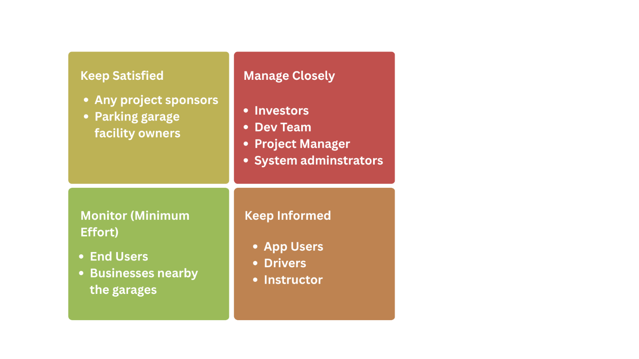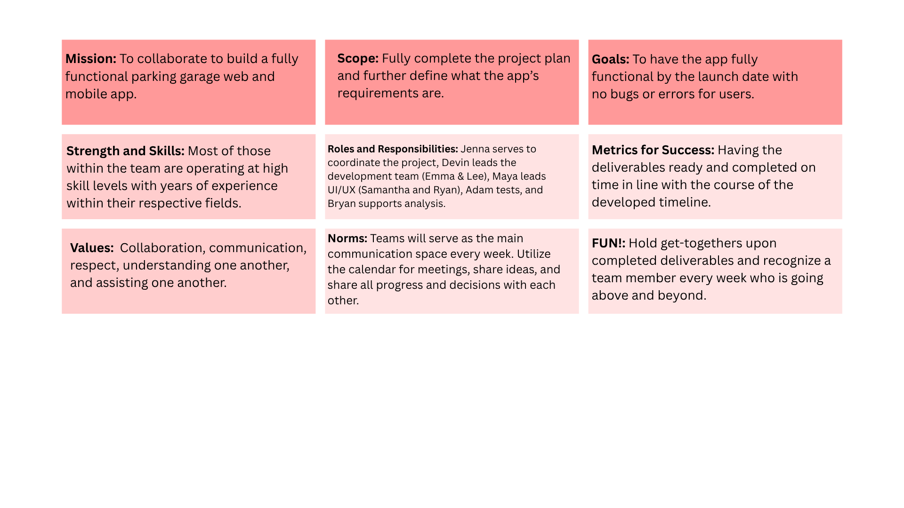

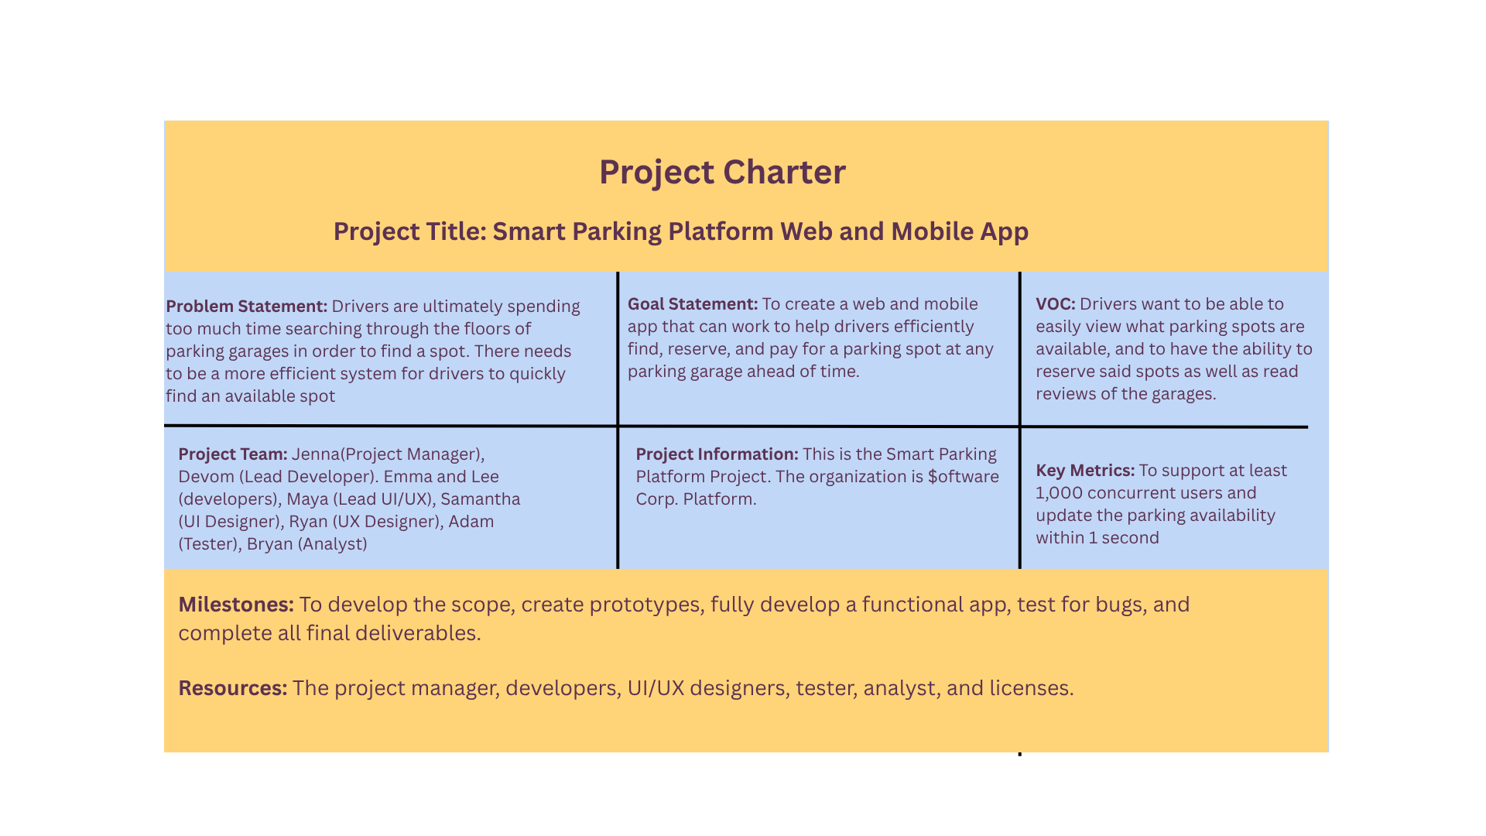

- Executive summary:
  - This project focused on creating a new app for both mobile and web that would make the parking experience easier for users by allowing them to locate available spots in parking garages, reserve them, and pay for them ahead of time.
- Achievements and shortfalls:
  - An achievement during this project was successfully identifying any bugs and ensuring that the app was functional for launch. A shortfall was not including enough time to gather user feedback or to conduct surveys on the app itself.
- Lessons learned:
  - One important lesson learned was the importance of setting realistic expectations and not going overboard on what can be reasonably accomplished. Taking into account possible risks is incredibly important for anticipating what could happen and finding ways to prevent potential issues. Consistent communication within the team to keep everything running accordingly is also vital.
- Recommendations for future projects:
  - For future projects it would be incredibly beneficial to establish more specific milestones throughout the timeline that are based on each team’s responsibilities.

